Subnetting with VLSM Exercise

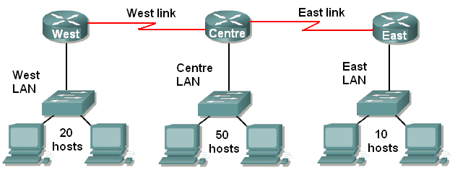

A network administrator has the address range 192.168.12.0/24 to address the networks shown.

- How many bits are in the network part of the address and how many are in the host part of the address?

- How many networks need to be addressed?

- Using older subnetting methods without VLSM, all the subnets need to be the same size. How many bits would you need to borrow to have enough networks?

- How many bits would be left in the host part?

- How many hosts could you have on each network?

- Can you address the networks without using VLSM?

7 From now on you will use VLSM to address the networks.
How many hosts are in the largest network?

8 How many host bits do you need to address these hosts?

9 How many bits are available for borrowing?

10 What will the subnet mask be when you borrow these bits?

11 How many addresses are there on a network of this size?

12 How many of these addresses can be used for hosts?

13 How many subnets do you get if you borrow this number of bits?

14 What are the network addresses of these subnets?

15 Fill in the first row of the table on page 2, using the lowest numbered network address and the name of your largest LAN

16 How many hosts will be needed on your second biggest LAN?

17 How many host bits do you need to address this number of hosts?

18 How many extra bits can you borrow, and how many bits are borrowed altogether?

19 What will the subnet mask be when you borrow these bits?

20 How many addresses are there on a network this size?

21 How many of these addresses can be used for hosts?

22 Start with the second network address that you listed in step 14. Enter your second network into the table.

23 Now deal with your third LAN. Although your third LAN is smaller, consider using the same subnet mask (and therefore number of hosts) as for your second LAN. This will allow room for growth.

24 Now deal with the two point to point links. There will never be more than two hosts on these links so you should use subnets that allow only two hosts.

Subnet name | Subnet mask | Network address | Broadcast address | Host address range

There is no single right answer. There are a lot of possible solutions.

You might like to show the numbers 0 to 255 in a table, and colour in your subnets to check that they do not overlap.

